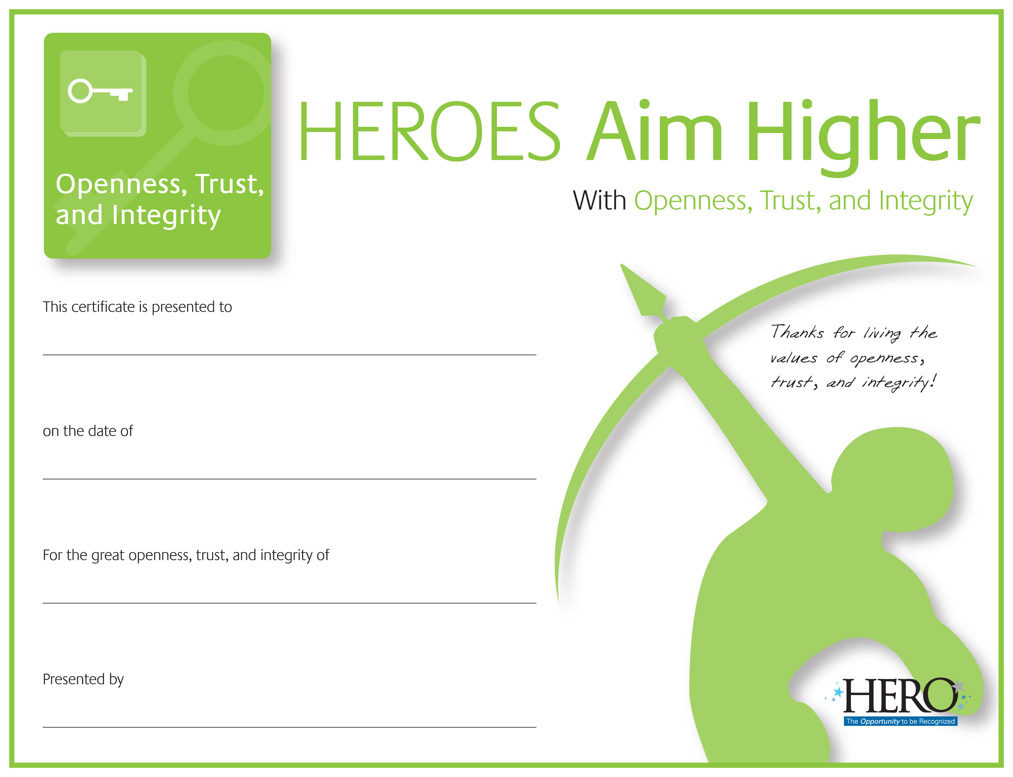
Enter Associate's Name Here
Enter a Date Here
Enter Text Here
Enter Your Name Here

